**Main screen**  (M24329 CybersecurityHolopod_SCREENSAVER_4Mb_vbr01)

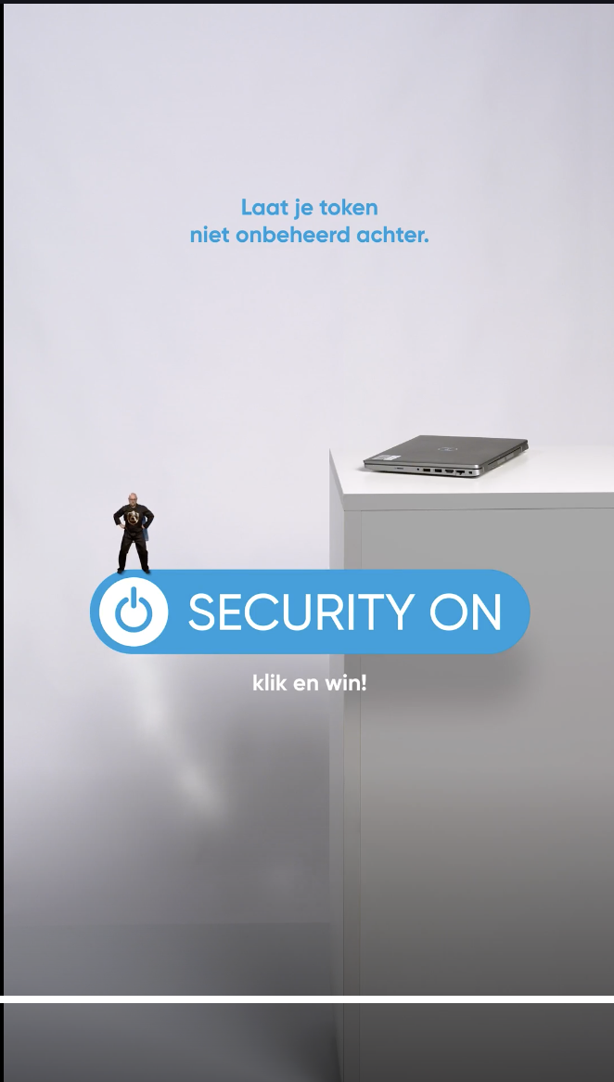 buttons should be in blue zone !

**Button 1** Agenda...

**Button-Imag**e = Button1.png

**Button-text =** Agenda

**Content behind button =** page showing Agendapage.JPG ( peter to deliver still)

**Button 2**  Discover...

**Button-Imag**e = boothicon.png

**Button-text =** Discover ...

**Content behind button =** atrium plan + animations when clicking on the fair items As discussed

Only active on the 6th of November : BUTTON 3

**Button 3** Win Prizes

**Button-text =** Win Prizes

Button-png: puzzleicon.png

Content behind button: The quizpage:

QUIZ PAGE:

There are 5 questions coming from a set of 5 x 2or3 questions

The user sees the text:

Security Quiz

Which is the most secure option?

Showing a right and a wrong foto from the first set at random

Score showing 0/5

After answering a random selection from the second set is shown

Again with a right and a wrong foto, same text above it...

Score showing 0/5 or 1/5 depending on the first answer...

And so on...

After answering anything of score not equal to 5/5: show text

Too bad...

You made some mistakes!

Do better next time.

Backbutton.png under it (half way the screen) leads to the main page

After answering right every time so with a score of 5/5: show text

You won!

Great skills...

Scan this QR code and fill in your name!

QRcode.png. ( file is not there yet)

Backbutton.png under it (half way the screen) leads to the main page